Title: Library Management System using Spring Boot and MongoDB

Technology Used:
- Java
- Spring Boot
- MongoDB
- Maven
- Swagger
- Postman

Submitted By :
Name : Priyanka Yadav
Reg No : 24BEY10039
Date : 18 JUNE 2026

1. Objective
The objective of this project is to develop a Library Management System that allows management of books, authors, members, categories, library cards, and issue records through REST APIs. The system uses MongoDB for data storage and Spring Boot for backend development.

2. Tools Used
Tool | Version | Purpose
Java | 24.0.2 | Backend development
Spring Boot | 4.1.0 | REST API development
Maven | 3.9.x | Dependency management
MongoDB | Installed Version | Database
MongoDB Compass | Latest | Database visualization
Swagger OpenAPI | 2.8.9 | API Documentation
Postman | Latest | API Testing
VS Code | Latest | Development Environment
GitHub | Latest | Version Control

3. Project Architecture
The project follows a layered architecture consisting of:
- Controller Layer
- Service Layer
- Repository Layer
- Model Layer
- DTO Layer
- Exception Handling Layer

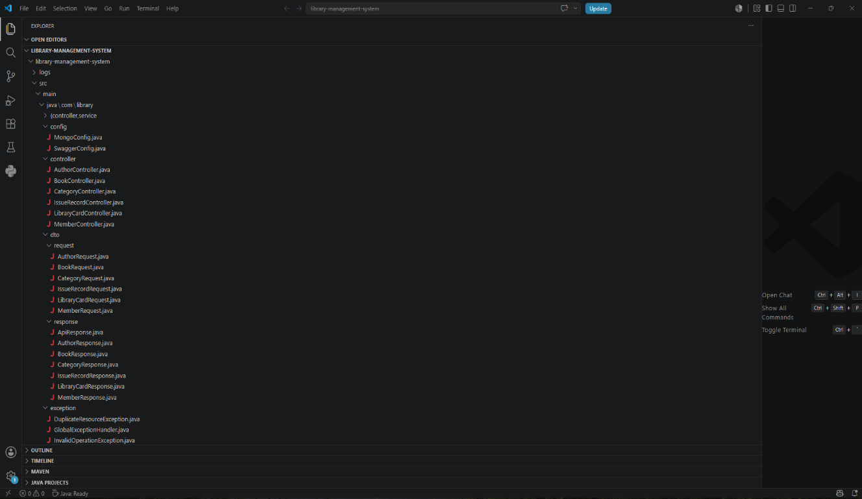

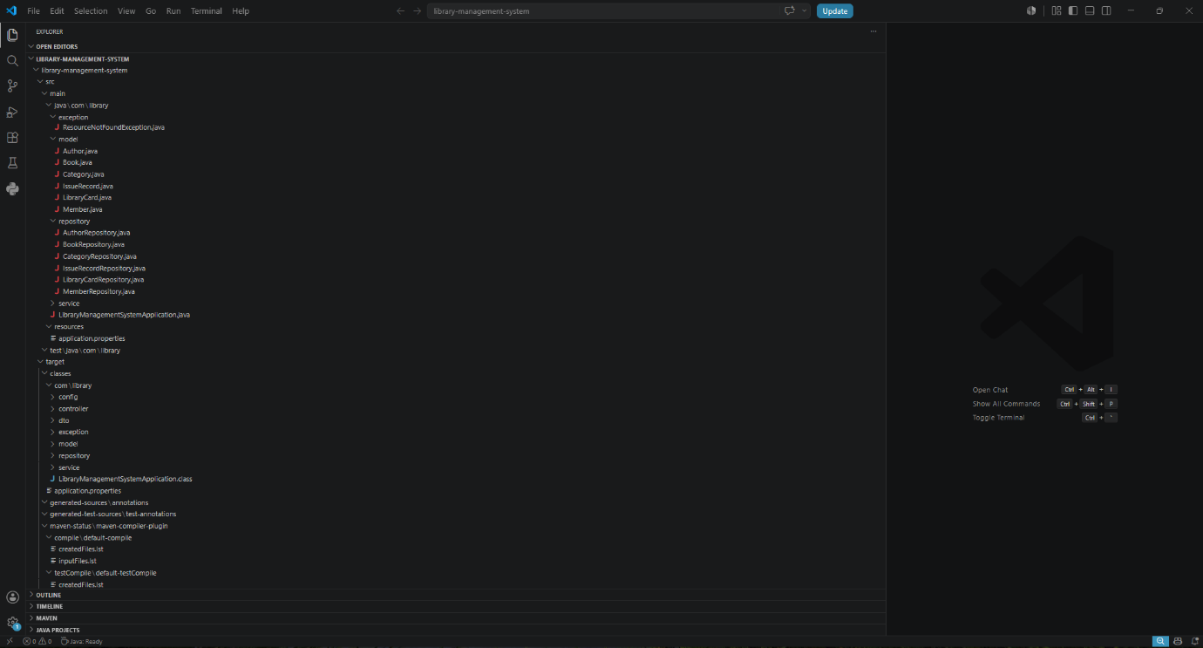

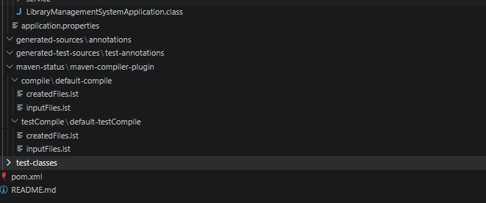

Explanation:
These images show the overall project structure organized into different packages following industry-standard architecture.

4. Database Configuration
MongoDB Compass was used to manage and visualize the MongoDB database. It helped in viewing collections, verifying stored records, and validating CRUD operations performed through the Spring Boot APIs. It was also used to monitor data for Books, Authors, Members, Categories, Library Cards, and Issue Records during testing and development.

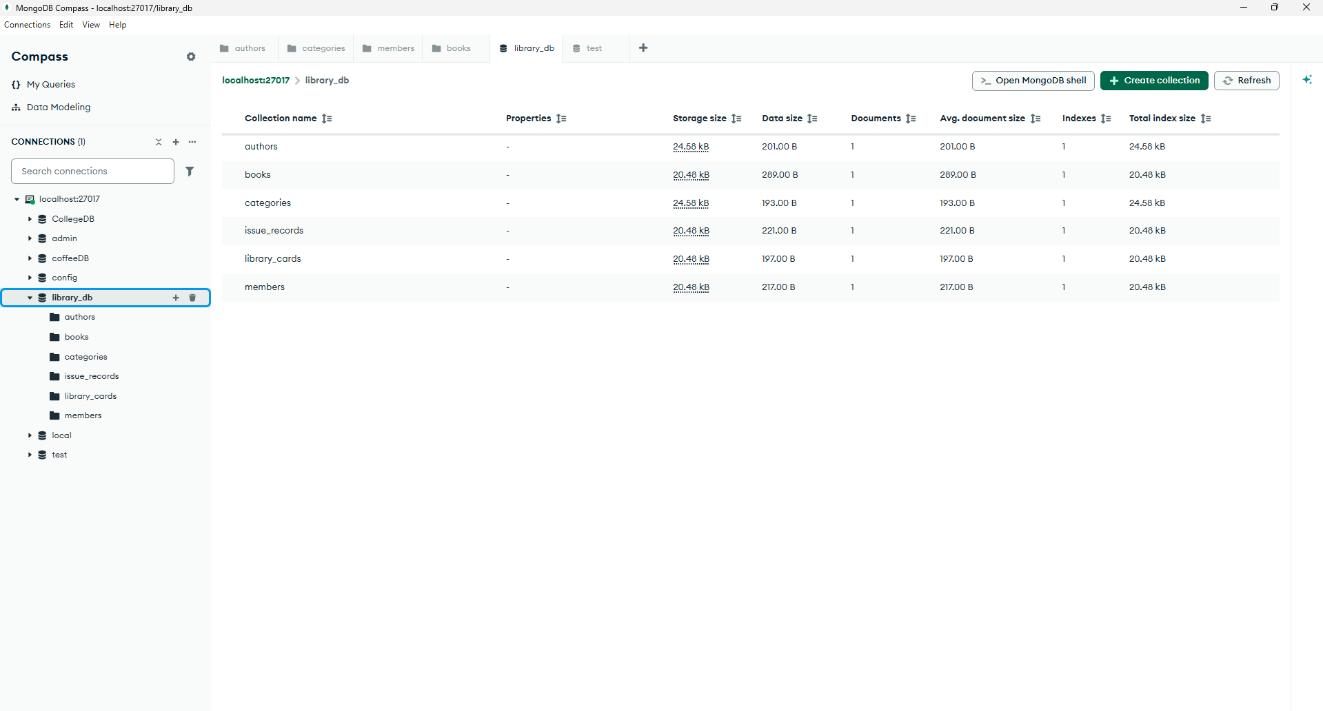

Explanation:
The image displays the MongoDB collections created for Books, Authors, Members, Categories, Library Cards, and Issue Records.

5. API Documentation using Swagger
Swagger was integrated to provide API documentation and endpoint testing.
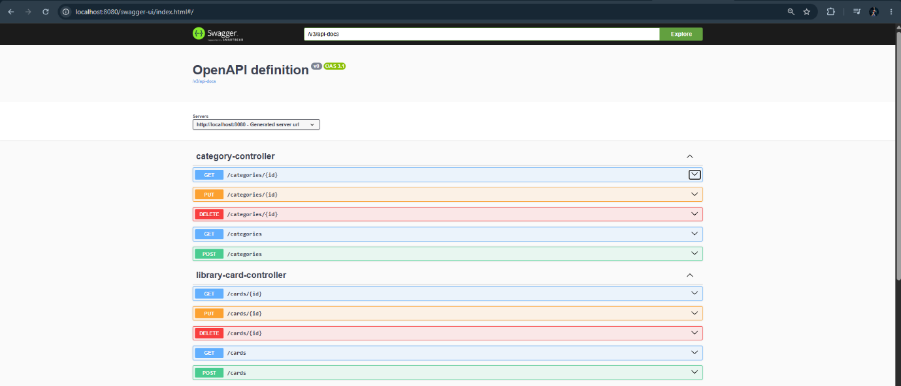

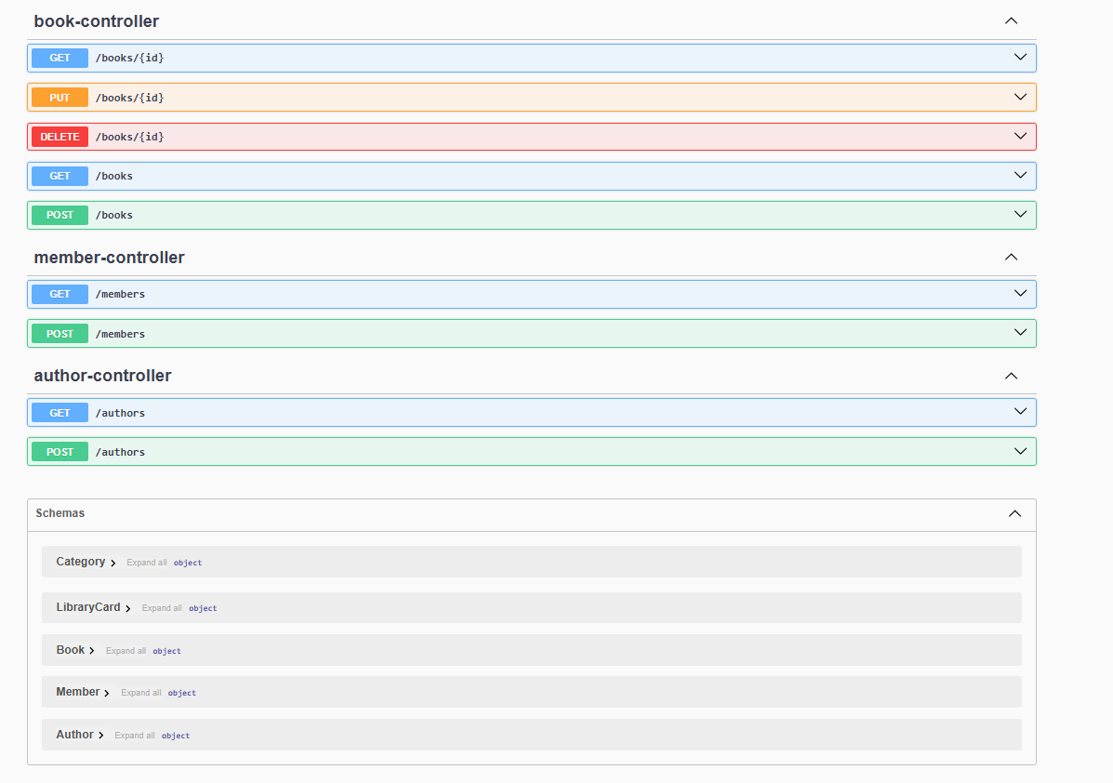
Explanation:
Swagger automatically documents all REST APIs and provides a user-friendly interface for testing them.

3. Tools Used and Their Usage
Java 24.0.2
Java was used as the core programming language for developing the backend application. All business logic, models, services, controllers, and repositories were implemented using Java.
Spring Boot 4.1.0
Spring Boot was used to build RESTful APIs and implement the layered architecture consisting of Controller, Service, Repository, DTO, and Exception Handling layers.
Maven 3.9.x
Maven was used for dependency management and project build automation. It helped in managing libraries such as Spring Boot, MongoDB, Swagger, and Validation dependencies.
MongoDB
MongoDB was used as the NoSQL database to store and manage data related to Books, Authors, Members, Categories, Library Cards, and Issue Records.
MongoDB Compass
MongoDB Compass was used to visualize collections, verify stored documents, and monitor database records during project development and testing.

Swagger/OpenAPI 2.8.9
Swagger was integrated to automatically generate API documentation and provide an interactive interface for testing REST endpoints.
Postman
Postman was used for API testing. CRUD operations and other endpoints such as Book Issue, Book Return, and Search APIs were tested using Postman requests.
Visual Studio Code (VS Code)
VS Code was used as the Integrated Development Environment (IDE) for coding, debugging, project management, and running the Spring Boot application.

